Session outline:
- Reflections on the future of cities and the future of urban modelling: Michael Batty (University College, London), Michael Wegener (Spiekermann and Wegener Urban and Regional Research), Marcial Echenique (University of Cambridge) – this part of the session will be broadcast live
- The live broadcast and recording will then cease at this point to enable plenary discussion
- Quick fire responses to the talks - all delegates
- Round table for general discussion on future directions of the AUM symposium
- Summary of the series
Session Chair: Marcial Echenique (University of Cambridge)
Session Host: Ying Jin (University of Cambridge)
Also could you add Michael Wegener’s photo and brief bio below (this can be taken from Session 1)
Bios of keynote speakers and chair:
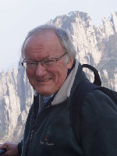 |  |  |  |  | Michael Batty  is Chairman of the Management Board of the Centre for Advanced Spatial Analysis (CASA) and Bartlett Professor of Planning (Emeritus) at University College London.  https://www.ucl.ac.uk/bartlett/casa/prof-michael-batty
[could you add Michael Wegener’s photo and brief bio here (this can be taken from Session 1; thanks!)]
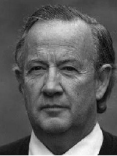 |  |  |  |  | Marcial Echenique  is Professorial Fellow of Churchill College and Emeritus Professor of Land Use and Transport Studies at the University of Cambridge.  https://www.arct.cam.ac.uk/people/me15@cam.ac.uk

