Railway engineering and the picturesque

Robert Thorne
Alan Baxter & Associates, United Kingdom
Introduction
Any consideration of the impact of the railways on the environment needs to take account of a fundamental change in attitude that occurred after the railways were first built. At the outset the impact of their construction - engineering works of an unprecedented magnitude - was regarded as intrusive and destructive, cutting great gashes through the landscape like a knife through cheese. The vocal opposition of famous writers such as Wordsworth, J.S. Mill and Ruskin, the assiduous lobbying against proposed lines by landowners, and hostile press reports about the works in progress all seem to confirm the impression that the railway juggernaut was permanently damaging to the countryside through which it passed [1]. Yet before long those same railway lines seemed to have been absorbed into the landscape. The sight of a train on an embankment or emerging from a cutting seemed as natural and reassuring as any other rural activity, and a journey by train revealed vistas of as much beauty as the pre-railway age.
These changes in perception may be attributed in part to the healing effects of time. Grass, wild flowers and trees covered the raw earthworks of the intrusive line and people became accustomed to the presence of the railway. Indeed eventually that familiarity merged into nostalgia as the railway became accepted as part of the everyday fabric of the community. Yet this change in attitude may also have had another cause, one which was actively contemplated when the lines were first designed. The manner in which they came to be accepted was not just because of the beneficent passage of time but because of the way they were originally tailored to the landscape.
The pioneer generation of railway engineers could draw on lessons from the building of canals and turnpike roads, in how to design and organise the works and supervise contractors. But they then had to apply those lessons to projects of an immensely greater scale, also taking account of the motive power of early locomotives. On every new line that was surveyed there was a clear set of engineering imperatives, not to mention tactical considerations in dealing with property owners and local political interests. But beyond these issues of utility and politics lay two other less tangible concerns, how the railway would be seen in the landscape and how it would be experienced by people who took the train. In dealing with those concerns those pioneer engineers could look to another kind of precedent, the well-established traditions of picturesque landscape design and picturesque travel.
That sense of the railway journey as a picturesque experience will be evident to anyone who has travelled along the Great Western line through Bath to Bristol or along the North Midland Railway line as it threads up the Derwent valley from Derby towards Chesterfield. Although now denuded of some of their original features these routes and the structures along them still seem to represent an engineering aesthetic of a particular kind which cannot be explained solely as the result of basic engineering necessities. It is these two lines which are the main subject of this paper, though no doubt there are others which could be used to illustrate the argument presented here. Also there are questions to be asked in examining the historic railway network as a whole about why that engineering aesthetic did not endure, a point taken up in the conclusion to this paper.
The picturesque landscape
The idea of the picturesque embodied a way of looking at the landscape which went beyond utility or basic amenity. The word ‘picturesque’ did not appear in the first editions of Samuel Johnson’s dictionary, but it was eventually cited in the 1801 edition with its derivation from the Italian pittoresco or the French picturesque. By 1801, although construction of the pioneering railways was still yet to come, interest in the picturesque had reached its peak. It is impossible to attribute its origins to any single event or person; instead two trends of thought can be detected from the early eighteenth century onwards. One was a literary ideal of the pastoral life, based on an admiration for the works of Virgil and Horace. The other, led primarily by Joseph Addison in his periodical the Spectator 1711-14, was an interest in the way that landscapes could evoke an imaginative response by triggering mental associations (nostalgia, melancholy, patriotism, etc.) [2]. These two trends together inspired the making of early eighteenth century landscape gardens which were sometimes, as at Stourhead in Wiltshire, actually laid out as Virgilian walks in which an educated visitor would recognise scenes from his works. Although the source of that experience might be literary it was of course experienced visually, as if the landscape was a painting or a series of distinguishable scenes. Through his designs the landscape gardener had revealed pictures in nature.
Before long that way of responding to the landscape had leapt beyond the confines of specially laid out gardens to influence the way travellers regarded their journeys. The key figure in this respect was the schoolmaster and cleric William Gilpin (1724-1804), who made the first of his travels ‘to criticise the face of a country correctly’ in the 1760s [3]. His tours resulted in a series of publications which started with Observations on the River Wye in 1782 and went on to include works on the Lake District, North Wales, the Scottish Highlands and the west of England. He tried hard to insist, in a schoolmasterly way, that these works were not precise topographical delineations but guides in how generally to recognise picturesque landscapes. That meant formulating views with particular ingredients (especially irregularity and roughness) and editing scenes to meet his formula. But despite his strictures most people went in search of the views he had illustrated, and newly-completed turnpike roads helped them plan their journeys. Thus all the regions he had visited began to have a tourist industry. For the Lake District alone, his publication was one amongst fifteen books for the traveller published in 1775-1800 [4].
At about the time he started on his travels Gilpin defined the picturesque as ‘expressive of that kind of beauty, which is agreeable in a picture’ [5]. Although that admirably summarised his aims, it left plenty of room for further discussion about the ingredients of a picturesque scene and whether picturesqueness was an inherent quality in certain kinds of object. These debates reached a climax in the writings of two gentleman theorists, Richard Payne Knight and Uvedale Price, which came out within months of each other in 1794. The back-wash from their differences was still being felt many years later: Jane Austen, who had read her Gilpin, knew that the responses to the picturesque from characters in two of her novels would be easily understood by her readers.
Gilpin purposefully avoided too much theorising and that was part of his appeal; also the fact that his books could be read by people who perhaps had no opportunity of creating a landscape of their own but enjoyed the idea of a tour in search of the picturesque. They could readily appreciate his idea of journeying from one frameable view to the next, perhaps recording each spot or simply relishing their ability to interpret his aesthetic formula. In an extraordinary flight of his imagination Gilpin even began to write a fictional tour circa 1800, never published. In a sense this was a template, showing how any journey could be transformed into a search for agreeable and curious features, some of them natural- valleys, rivers and openings between hills or mountains- but also buildings and ruinous structures, the stranger the better [6]. He imagined that the tourist would be travelling by road or river, but his way of viewing the landscape in motion was later instinctively adopted in descriptions of journeys by train.
Where structures in the landscape were concerned, Gilpin preferred ancient, ruinous or broken features rather than the busy activity of new buildings [7]. But for those who had the means to create or redesign their own landscape the idea of including buildings in the view, whether useful or not, was positively welcomed. They might be purely emblematic, and that could include artificial ruins or, as at Stourhead and countless other landscape gardens, complete structures evocative of specific connotations; or they might provide housing or other useful functions. In the Age of Improvement, which merged with the coming of the railways, a landscape which could be useful and profitable as well pleasing seemed ideal, and that inevitably meant providing new buildings. But those buildings- cottages, villas, schools and other facilities- could be treated architecturally in the associational styles of the older picturesque tradition. The Tudor lodge house or the castellated villa might not carry the same exact meanings as the garden buildings of the early eighteenth century, but a residual echo of the same intention was still evident. Architectural writers such as J.C. Loudon (1783-1843) and P.F. Robinson (1776-1858), who acknowledged their debt to Uvedale Price and other theorists of the picturesque, produced pattern books and publications which popularised these ideas of associational architecture just as the railways were coming into being [8].
Engineering priorities
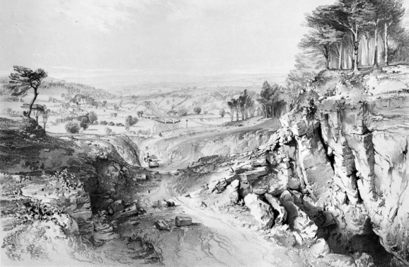
The engineering of a new railway line took as its starting point the places to be served but thereafter was a balancing act between geography and costs. Roads typically followed the natural terrain but could include gradients as steep as 1:20. The locomotives of the early railways demanded much easier gradients or, where that was not possible, cable haulage. Thus the Stephensons aimed for a gradient no steeper than 1:330 on the London & Birmingham Railway, with cable power for the last section of the route into Euston Station. On the Great Western route from London to Bristol, Brunel sought to meet an even more ambitious target of nothing steeper than 1:660, but had to include two steeper inclines. The way to achieve these levels was wherever possible to follow the natural contours formed by river valleys or gaps between hills, many of which had already been used by earlier roads and canals. Sometimes the terrain dictated that a railway had to miss a major town, Northampton in the case of the London & Birmingham or Sheffield on the original route followed by the North Midland Railway. Such places remained stranded on loops or branches until the railways could afford to give them better connections. One other general consideration cited by Frederick Swanwick of the North Midland was that by taking a line down the centre of a valley a railway could optimise its connections to local industries and mines, serving both sides of the valley and minimising the amount of transhipment onto the railway [9].
Fig. 1. The G.W.R. line at Bathwick, on the approach to Bath, from J.C. Bourne, History and Description of the Great Western Railway (1846)

Once the route strategy had been determined, more detailed surveys took into account a further set of issues- the exact landtake required for the line, geology, subsoils and drainage. Although the Act of Parliament for a railway gave a company powers of compulsory land purchase, the negotiations over price with property owners (including compensation for loss of amenity) might influence the exact choice of route and powerful landowners often, in addition to compensation, forced companies to include features (especially tunnels) to preserve views across their property. Above all hung the aim of avoiding costly earthworks. The construction of the pioneering main railway lines of 1834-41 each involved an average of 2-3 million cubic yards of excavation or embanking per year, all done by navvies or horse power [10]. Ideally the volume from digging a cutting equalled that need for a nearby embankment: where that wasn’t possible, disposal of the fill involved yet more negotiations with landowners. Tunnels were to be avoided wherever possible and bridges carefully graded to their functions, from the simplest timber occupation bridges for farmers to substantial masonry or iron bridges for turnpike roads and rivers.
On top of all of these issues, any insistence that a line be laid out according to a particular landscape aesthetic might have seemed an impossible luxury. It is certainly true that landscape theories did not feature in the professional discussions of railway engineering techniques, which mainly focused on structural designs, earthworks, costing and contract organisation. Also, it might be argued that where a railway appeared to be specially landscaped that could be just the unintended result of a line laid out to follow the natural contours. Yet in studying the lines as built, including the buildings and structures along them, there often appears to be evidence that engineers had in mind more than just strategic and practical objectives. Their aim was to make the railway more than just a utilitarian achievement.
The great western railway
The two lines to be considered here in more detail were both part of the pioneering railway era of the 1830s. As first planned in 1833 the Great Western Railway was to be the longest line in the country, 118 miles from London to Bristol. From the time of the first route surveys the company’s engineer, Isambard Kingdom Brunel, showed his determination to control and interrogate every aspect of the engineering design and to stamp the project with his convictions. He was, as his many biographers have emphasised, an unorthodox outsider distinguished in having a far-reaching imagination coupled with a highly-developed analytical ability; in Steven Brindle’s words, ‘synoptic brilliance’ [11]. He also had a discerning eye for architectural form and landscape. His brother-in-law J.C. Horsley recalled his love of landscape art and his ‘keenest appreciation of the beauties of nature’ [12]. Under his command the Great Western project was bound to be exceptional in almost every respect.
As a result of his first surveys Brunel decided on a line from London to Bristol known as the ‘northern’ route, ‘superior on every account’ [13]. This followed the Thames valley through Reading to a gap in the end of the Chiltern Hills at Goring, before striking westward across the Vale of the White Horse and through Chippenham to join the valley of the River Avon near Bath. The Avon was crossed five times. Brunel favoured this route because he could achieve an almost level line, with the exception of an incline at Wootton Bassett, east of Chippenham, and a descent into Bath through Box Tunnel. The company directors agreed to his preferred route even though it missed some well-established towns along the way. They also accepted the case he made for the other distinguishing characteristic of the line, the use of a 7ft. 1/4in. gauge rather than the 4ft. 8 1/2in. gauge which was fast becoming the generally accepted standard throughout the country. This meant that the width of a typical two-track line had to be 30ft. and the embankments and cuttings correspondingly wider. The radius of curves also had to be more generous. Because Brunel’s broad gauge trains were designed to have a low centre of gravity the bridges and other structures along the line were no higher than on standard gauge lines. But even if there was no gain in height, a line designed for broad gauge was bound to have a certain intrinsic grandeur because of its technical requirements.
After a false start in 1834, the Act of Parliament to build the line was passed in 1835. Construction started the same year, proceeding from the two ends of the line. Brunel appointed engineering assistants for both parts, but made initial sketches of every feature himself - earthworks, bridges, viaducts and stations - and supervised the drafting of all the contract specifications. The line began to be opened at the London end in 1838 and had reached westwards for over 60 miles before the first section at the Bristol end was completed. That section was always going to be the more arduous because of the terrain and the number of tunnels involved. Some of these tunnels were quite short, so much so that a few were later opened out, but Box Tunnel, over 1 ¾ miles long, was the major engineering feature on the line involving three contractors for five years. With its completion in 1841 trains could be run along the whole route for the first time.
One of the engineers that Brunel employed in building the Great Western line was George Thomas Clark (1809-98), subsequently better-known as a South Wales ironmaster and an indefatigable antiquarian nicknamed by contemporaries ‘Castles Clark’. Although his time with Brunel lasted no more than seven years it is through what he wrote about his chief and the line he masterminded that we can best appreciate the frame of mind in which the design evolved. In this respect Clark’s most interesting contribution is the text he wrote to accompany John Cooke Bourne’s famous book of lithographs, The History and Description of the Great Western Railway (1846) [14]. J.C. Bourne (1814-96) had started sketching the construction of the London & Birmingham Railway in 1836, combining an assured understanding of the works involved with an artist’s eye for dramatic effect. Encouraged by the antiquary John Britton he lithographed thirty-six of his drawings, which he published in 1838 with an introduction by Britton. The success of this project - there were many reprints - led him to embark on a similar celebration of the Great Western, though by the time he took up that subject construction was more advanced than when he had done the drawings of the London & Birmingham, so he found himself recording more of the completed line than works in progress. How Bourne met G.T. Clark is not recorded, but in an anonymous book review which he wrote three years before he died Clark referred obliquely to his role, not just in preparing Bourne’s volume but in pointing Bourne towards the best subjects for illustration [15].
The relationship between Bourne and Clark brought together an artist steeped in a landscape art tradition with an engineer keen to expound the relevance of that tradition to the engineering of the Great Western route. The preamble to Bourne’s book immediately outlined what that relationship might mean for the reader: ‘it is…hoped that drawings sufficiently correct for the purposes of the engineer or the architect will please also the general lovers of the picturesque’ [16]. Here therefore was an exposition for the armchair reader or future traveller, much in the tradition of Gilpin’s travel books, of how the line could be seen and experienced. Of course the difference was that whereas Gilpin had sought out the picturesque in the natural landscape, the Great Western was a commercial enterprise consciously adopting that ideal as part of its public persona. Brunel and his colleagues, plus Bourne as their interpreter, wanted the line to be appreciated as a specially landscaped journey.
That awareness of the traveller’s experience permeates Bourne’s book, in the text and lithographs alike. Clark’s text flatters the line’s uses by emphasising that the inhabitants of towns along the Great Western ‘indulge in higher comforts’ than those living on other lines in the industrial Midlands and the North [17]. By implication such people, like Gilpin’s educated excursionist, would be better fitted to understand the distinctive features of the line. They would be aware not just of the antiquities and country seats seen from the train window or the geology exposed in the railway cuttings but also the character of the line itself. In particular they would approve of the way the structures and buildings along the route showed a progression in materials and style, evoking local associations just as a landscape gardener would use structures as aides to memory and reflection.
Despite many alterations and losses since Brunel’s time that sense of progression can still be clearly felt today, especially at the Bristol end of the line. In Bourne’s book the sequence is described as starting at the London end in an Egyptian idiom with the monumental brick piers of the Wharncliffe Viaduct. Egyptian merged into classical in the next large bridges and viaducts at Maidenhead, Gatehampton and Moulsford, all similarly of brick with stone dressings. Meanwhile the stations from London to Swindon (almost none of which survive in their original form) varied from a spare classicism for wayside stops to a more ornate Italianate for larger stations. But just before Swindon a watchful traveller could (and still can) detect a change in mode and materials at the Roman Road bridge, so called because it carries a road on the alignment of the Roman Ermine Street across the tracks. Brunel chose this point on the line to switch from brick to predominantly stone construction and also, because of the revered associations of the Roman highway, to forsake the elliptical arches of most of his bridges in favour of a single semi-circular arch springing almost from track level. This bridge is an appropriate prelude for the approach to Bath from Chippenham, in which the Roman grandeur of the structures on the line spells out the importance of the next major stopping place. Brunel treated the tunnel portals on this section - the west entrance to Box Tunnel and both portals of Middlehill Tunnel - as Roman Doric structures, Middlehill even having the Roma fasces in panels on the massive piers which flank the entrances. The bridges, all of fine stone ashlar, echo that theme. They could be savoured not just by the traveller but in particular at Bath itself by promenaders in the Sydney Gardens. Forced by the hilly topography of the city to take his line through the 1790s layout of these public gardens, Brunel treated his engineering as a linear landscape feature, with bridges, a short tunnel and elegant concave retaining walls demarcated by broad pilasters. Here as nowhere else the historic picturesque tradition overlapped with his interpretation of it.
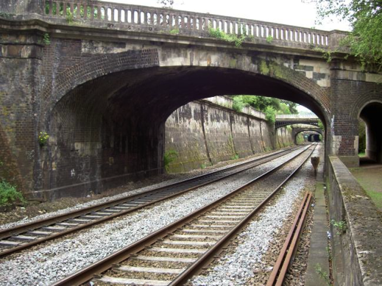
Fig. 2 The Great Western Line in Sydney Gardens (Alan Baxter & Associates LLP)

But Bath as well as being Roman could also claim a medieval past as a walled and gated city with a fine Abbey church rebuilt in the early sixteenth century. Perhaps that, plus a desire to woo aristocratic passengers, explains why Brunel chose to make Bath Station a Flemish-gabled country house, described by Clark as ‘of the period of James I, with debased Gothic windows and Romanesque windows’ [18]. That Tudor-Jacobean theme continues down the line to Bristol, first in the castellated St. James’s Viaduct, built on the site of the city’s medieval south gate, then the bridges and viaducts which follow along the valley of the Avon. Even the smallest bridges are formed of four-centred Tudor arches, and as the line approaches Bristol it crosses the river on a Gothic arch squeezed between octagonal buttresses. Bourne illustrated most of the tunnel portals on this section of the line, from viewpoints (perhaps chosen on Clark’s advice) which highlighted their picturesque impact. All those that survive- one of the tunnels was opened out in the 1880s - are castellated and turreted, sometimes with the added asymmetrical effect of one tower shorter than the other or one round and the other square. In two places Brunel took the idea of a tunnel as natural feature one step further. At Fox’s Wood Tunnel he chose to keep the hewn rock of the east portal as the navvies left it, as if the railway was entering a secret cave, and at St. Anne’s Park Tunnel, where a landslide partly destroyed the Romanesque west entrance, he left that damaged section as a semi-ruin as if time had set its mark on an ancient structure.
Brunel was able to continue the Tudor-Gothic theme into the Temple Meads terminus at Bristol, but not before the committee for that end of the line had assessed, and had costed, two Gothic proposals and an alternative ‘Italian’ design. As reported by the committee secretary, their preference for a simplified Gothic design was made on the same associational grounds as had helped determine Brunel’s architectural choices throughout the route. The Italian submission would have cost slightly less, but had the sparseness of ‘any Union Poor House in the Country.’ The Gothic, by contrast, held connotations suited to Bristol’s past - the cathedral and the nearby church of St. Mary Redcliffe - and conformed to the style already established for their section of the line. So Tudor-Gothic won the day, for both the frontage building (with an oriel window for the committee’s offices) and the cleverly contrived hammer-beam roof of the station behind [19]. A traveller starting out from Bristol, especially of the wealthy sort the company hoped to attract, could be under no illusion about the design sequence they were about to experience.
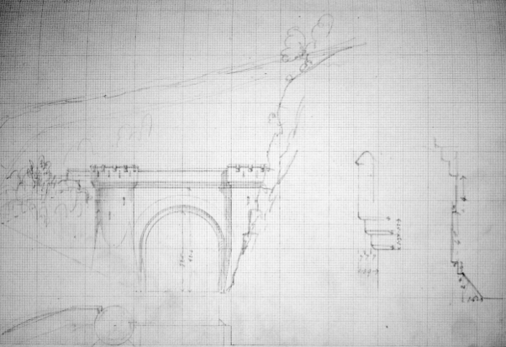
Fig. 3. Initial design by I.K. Brunel by Fox's Wood Tunnel west portal (Brunel Collection, University of Bristol)

The North Midland Railway
The second line to be considered here had its genesis slightly later than the Great Western but was completed a year earlier. The North Midland Railway from Derby to Leeds was promoted as part of a strategy to link Leeds and West Yorkshire with London. The initial mastermind behind the proposal was the engineer George Stephenson (1781-1848) who was also engineer for two of the other lines which were to help form that route, one north from Leeds and the other south from Derby to Birmingham. He made to first surveys to determine the route in 1835 along with his assistant Frederick Swanwick (1810-85), who had served his apprenticeship with him and for a time had acted as his private secretary. Swanwick subsequently made more detailed surveys of the route and it was he who took the lion’s share of defending the proposal when the necessary Bill came before Parliament [20]. The Act to build the line was passed in 1836.
When the full engineering appointments were announced George Stephenson was made chief engineer jointly with his son Robert Stephenson (1803-59) [21]. But because his son was still fully committed on the building of the London & Birmingham Railway he was unable to give much attention to the North Midland project until about two years later. In the meantime it was Swanwick, appointed resident engineer, who was most closely involved in its detailed development - the design of the line and its structures, the letting of contracts and the supervision of the works. This was to be the most important project of his career (he retired in 1850), and although his personality is not as clearly etched as the Stephensons or Brunel he was known to have had a particular love of landscape which infused his railway engineering. Of his North Midland works it was remembered that he ‘devoted untiring energy to make them permanent and absolutely sound…and without sacrificing reasonable beauty of design’ [22].
Thus, even before an architect became involved on the North Midland project, decision-making was more widely devolved than on the Great Western. That was typical of the Stephensons’ method of team working. This makes it harder to identify who amongst those responsible provided the most design input, but much of the evidence points to Swanwick as the person who had greatest regular control over the evolution of the project.
The terrain which the line had to cross included at its southern end the lower Pennines. The way through these hills selected by George Stephenson and Swanwick involved following the valleys of the Rivers Derwent and Amber in Derbyshire before crossing the watershed to the River Rother in Yorkshire. Tunnels were inevitable, especially the Clay Cross Tunnel (1760 yards long) dug at the highest point on the route. Even when following the lie of the land as much as possible, the earthworks involved for cuttings and embankments were formidable: an average of 131,000 cubic yards per mile compared with 85,000 cubic yards per mile on the Great Western [23]. And despite those works there remained some sharp gradients, the worst at 1:260 [24]. Engineering costs meant that although the company served some of the towns along the route, especially Chesterfield, it was prevented from including Sheffield in its plans and only skirted near to others. But against those drawbacks could be put not just the planned connection to London but also a territory rich in mineral workings that could yield a profitable goods traffic.
In July 1839 the company chairman George Carr Glyn reported on an inspection he had made along the line. Except at Derby most of the stations and subsidiary buildings had yet to be built but he was confident that the railway could be opened the following year. He delighted to report on the quality of what had so far been achieved: ‘It is impossible to proceed along the Derwent and Amber vallies (sic) without being struck with the boldness as well as the ingenuity which have designed these works’ [25]. Much of what he praised can still be seen today, the route in its completeness and most of the historic structures along it. The bridges, mostly segmental or semi-circular single span arches but some triple span, are exquisitely built in local sandstone or gritstone. All have carefully worked voussoirs, roll mouldings and copings which merge into the curved or angled wing walls. In one particular sequence, through the mill town of Belper, eleven bridges cross the line in close succession linked by the stone-lined walls of the cutting. This railway slice through the streets of the town has an urban drama easily comparable to Brunel’s Sydney Gardens. The tunnels, which were largely complete when Glyn made his inspection, also still provide evidence of the attention given to the visual impact of the line. This is especially true of the north portal of Milford Tunnel with its seven concentric rings forming a Romanesque arch in an artificial rockface, described as ‘a rich Saxon arch’ when built, and the turreted north portal of Clay Cross Tunnel, appearing to the same author as being like ‘a magnificent Moorish gateway’ [26]. Others of the seven tunnels along the line were more plainly treated, but still recognisably in the same overall design idiom.
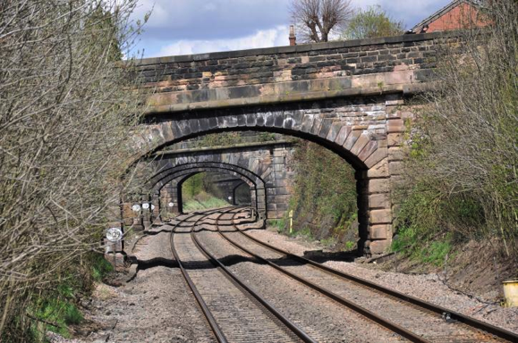
Fig. 4. The North Midland Railway in Belper (Alan Baxter & Associates LLP)
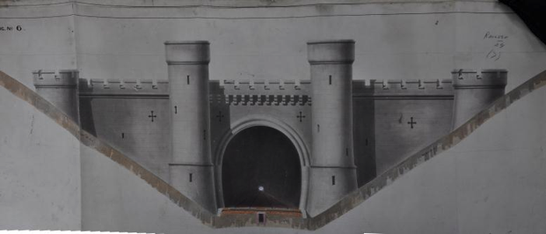
What do not survive, with one exception, are the wayside stations and the ancillary buildings which accompanied them. The plans for these were not made until the engineering works were well advanced. Early in 1839 the directors accepted Robert Stephenson’s recommendation to use Francis Thompson (1808-95) as their architect, who he had already employed on the London & Birmingham Railway [27]. Thompson finished the drawings for the stations by September that year. Ultimately there were to be twenty-four, all of them designed in the mode of lodges on a road through a country estate. In plan most of them were similar, of single story parallel to the platform, with a central projecting section for the station office flanked by side wings: there was no platform canopy. Houses for station staff were provided separately. For each station the standardised form was given a different architectural treatment, with the kind of intentional variety of an improving landlord providing cottages for his workers. Thompson’s styles ranged from a stripped Grecian, as in the surviving example at Wingfield, via Italianate to a fully-gabled Jacobean, and the materials changed to suit the locality. The choice of styles seems random compared to Brunel’s unfolding progression along the Great Western, but the idea of an associational aesthetic to please the traveller was the same.
Fig. 5. Clay Cross Tunnel north portal (The National Archives Rail 530/29)
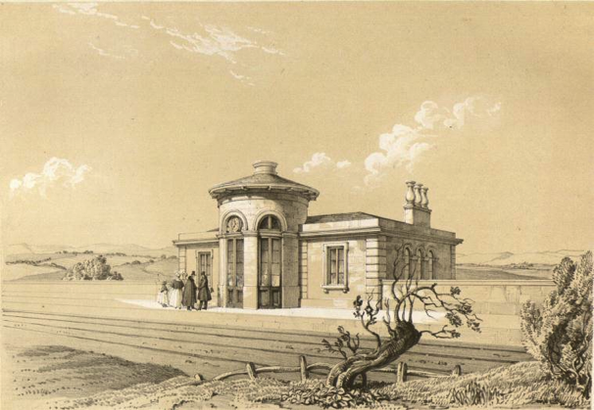

Fig. 6. Eckington Station, lithograph by Samuel Russell (Baker Library Collection, Harvard Business School)

Thompson hoped to publish a book illustrating his North Midland buildings, for which the lithographic artist Samuel Russell prepared at least eleven drawings. He had in mind perhaps the success of J.C. Bourne’s book about the London & Birmingham Railway but, despite the good publicity that might be gained from such a publication, the company turned down his request for financial backing [28]. Because the North Midland lacks a contemporary description written from inside knowledge, like that which G.T. Clark provided for Bourne’s work on the Great Western, it is harder to ascertain what lay behind the designs and how those involved interacted. However there is enough evidence, including that of the surviving engineering structures, to substantiate certain conclusions.
The promoters of the North Midland were mainly interested in its potential freight traffic. Unlike their counterparts on the Great Western there is little to suggest that they set a priority on attracting wealthy passengers through the design of the line and its structures, though they did concede to having highly characterful intermediate stations. Nor is there much evidence that landowners along the route forced the company, as landowners did elsewhere, to mitigate the visual impact of the railway. The one exception was Sir William Pilkington of Chevet Hall near Wakefield who bargained actively to have a longer tunnel and a viaduct ‘faced with Ashlar stone’ where the line affected his property [29]. The Strutt family of Belper, by far the most important industrialist landowners on the route, might have been expected to exert the same proprietorial interests. On two occasions they did indeed force the company to review the proposed route, employing surveyors to produce alternatives. On the first occasion, before the Act of 1836 was passed, they reached an amicable agreement about the route alignment south of Belper, a route which the company subsequently amended to produce a better-engineered line. Later in 1838 they successfully sought changes in way the line passed through Belper itself. It would seem that their concern was as much to do with the River Derwent, which powered their Belper mills, as it was to do with the visual aesthetic of the line [30].
Though the Strutts may have exerted influences that are not recorded, it seems that the care given to the relation between railway and landscape - in both the overall alignment and the detailed engineering - is mainly attributable to the Stephensons and Frederick Swanwick. The company only showed interest in their designs when it appeared they were overreaching themselves. Whereas the Great Western directors fully engaged with Brunel’s arguments for appropriateness of Gothic, the North Midland committee objected to the ‘expensive ornament’ of Swanwick’s castellated Clay Cross Tunnel portal. In reply he cited its additional cost – ‘very trifling’ - rather than seeking to advance an aesthetic justification [31]. Generally the Stephensons and Swanwick made implicit design decisions which did not attract the notice of the directors; until, that is, their significance was praised by the Chairman in 1839. As for the architectural contribution of Francis Thompson, his appointment came long after the fundamental design decisions had been made. As well as his stations it seems that he contributed to the Romanesque north portal of Milford Tunnel [32]. He was obviously sympathetic to the way the line had evolved and was trusted by Robert Stephenson to help give it the right architectural finish.

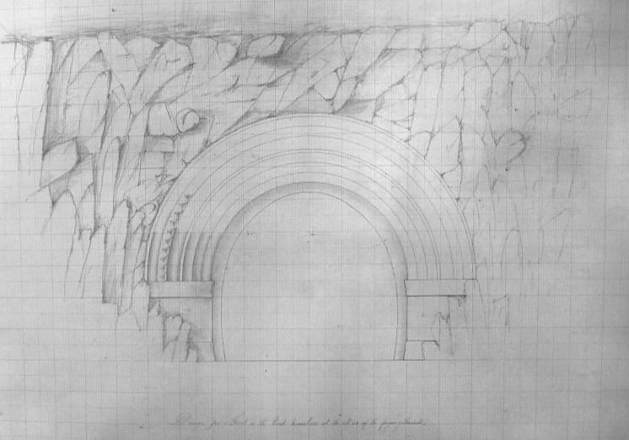
Though Thompson failed to get backing to publish a book of his designs, his work for the North Midland found an outlet that located it clearly in the picturesque tradition. J.C. Loudon, who did as much as anyone to instil picturesque principles into architectural practice, published four of Thompson’s station designs in the supplement to a revised edition of his popular Encyclopaedia of Cottage, Farm and Villa Architecture, published in 1842. They appeared there is a slightly modified form, changed from railway use to suburban villas. So Thompson’s imitators were still to be seen long after most of his original stations had been demolished [33].
Fig. 7. Design for Millford Tunnel north portal, possibly by Francis Thompson (National Railway Museum, York, 2001-9508)
A new picturesque
The approach to engineering a railway in the landscape typified by the work of Brunel, the Stephensons and Swanwick failed to survive during the subsequent development of the railway system. The first generation of railway engineers were stimulated by the idea of the train journey being an unfolding experience of sights and impressions. As trains got faster it was harder to appreciate passing features, and as railway travel became familiar there seemed to be less need to make it palatable or interesting by giving the line a special treatment. Also the additional cost of such treatments became harder to justify. The stylistic changes, which Brunel rang along the Great Western were, it was said, introduced ‘at moderate cost’ and the line to Bristol was certainly successful [34]. That was not the case with the North Midland, which had been unusually expensive to build and yielded extremely disappointing returns, leading to severe retrenchment and the sacking of staff, including Francis Thompson [35]. Its recovery only began once it had been amalgamated in 1844 with its adjoining companies to form the Midland Railway.
It also became more obvious over time that railways, even if austerely engineered with no architectural additions, could quickly assimilate to the landscape once the disruption caused by their construction had passed. An editorial in Builder of 1876 (probably by its editor George Godwin) was bold-faced enough to suggest that even in the Derbyshire Peak District, a favourite battle ground for defenders of Romantic landscape, the railway could be a picturesque addition; ‘in many, not to say in most cases, an addition to, rather than a detraction from, the picturesque character of the scene, and even…a new element of what may be called the mental or moral picturesque.’ The idea of a moral picturesque, which stretched the term well beyond its original meaning, was manifest in the way the railway linked town and country in a ‘bond of civilised life.' Thus the railway was given a new, wholly unapologetic place in the landscape [36].
References
This paper derives from work undertaken by Alan Baxter & Associates on the conservation aspects of the electrification of the Great Western Main Line and the Midland Main Line. I am most grateful for many stimulating discussions with my ABA colleagues Tom Brooks, William Filmer-Sankey and Richard Pollard.
[1] Gordon Biddle, The Railway Surveyors. Shepperton, Surrey: Ian Allan Ltd., 1990, pp. 83-88; Jack Simmons, The Victorian Railway. London: Thames & Hudson, 1991, pp. 162-3.
[2] P.M. Harman, The Culture of Nature in Britain. London and New Haven: Yale University Press, 2009, pp. 93-113; Malcolm Andrews, Landscape Aesthetics and Tourism in Britain 1760-1800. Aldershot, Surrey: the Scholar Press, 1990, pp. 4-17, 39-41.
[3] C.P. Barbier, William Gilpin. His Drawings, Teaching and Theory of the Picturesque. Oxford: Oxford University Press, 1963, p. 49.
[4] Peter Bicknell, The Picturesque Scenery of the Lake District 1752-1855. A Bibliographic Study. Winchester: St. Paul’s Bibliographies, 1990, p. 3.
[5] An Essay Upon Prints, 1768, p. x quoted in Andrew Ballantine, Architecture, Landscape and Liberty. Richard Payne Knight and the Picturesque. Cambridge: Cambridge University Press, 1997, p. 82.
[6] C.P. Barbier (note 3), pp.138,177-80.
[7] C.P. Barbier (note 3), pp.112-16; Stephen Copley, “Gilpin on the Wye: Tourists, Tintern Abbey and the Picturesque,” in Michael Rosenthal et al, Prospects for the Nation: Recent Essays in British Landscape 1750-1880. London and New Haven: Yale University Press, 1997, pp. 133-55.
[8] Christopher Hussey, The Picturesque. London: Frank Cass, 1967 (first published in 1927), pp. 224-30. G.L. Hersey pointed out that Loudon believed architectural meanings should be based on building function, i.e. they shouldn’t be applied as pure style: “J.C. Loudon and Architectural Associationalism”, Architectural Review, August 1968, pp. 89-92.
[9] (T)he (N)ational (A)rchives: RAIL 1066/2385. House of Commons Committee on the North Midland Railway Bill, p. 16.
[10] A.W.Skempton, “Embankments and Cuttings on the Early Railways”, Construction History, Vol.11, 1996, p. 33.
[11] Steven Brindle, “I.K. Brunel - First Amongst Equals?” Transactions of the Newcomen Society, Vol.78, No.1, 2008, p. 508.
[12] Isambard Brunel, The Life of Isambard Kingdom Brunel. London: Longmans Green, 1870, p. 508.
[13] Quoted in Andre Gren, The Foundation of Brunel’s Great Western Railway. Kettering: Silver Link Publishing, 2003, p. 54.
[14] The attribution of the text to Clark is made in Oxford Dictionary of National Biography Vol.11, 2004, p. 803.
[15] “The Birth and Growth of the Broad Gauge”, Gentleman’s Magazine, Vol.279, 1895, pp. 489-90. The attribution of this article is also given in Clark’s ODNB entry.
[16] J.C. Bourne, The History and Description of the Great Western Railway. London: David Brogue, 1846, p. iii.
[17] J.C. Bourne (note 16), pp. 11, 30, 57.
[18] J.C. Bourne (note 16), p. 51.
[19] Steven Brindle, Brunel. The Man Who Built the World. London: Weidenfeld & Nicolson, 2005, pp. 22-4.
[20] TNA; RAIL 530/6. North Midland Railway London Committee, Sept.9th. 1835; John Frederick Smith, Frederick Swanwick, Privately Printed, 1888, p. 15.
[21] TNA: RAIL 530/2. North Midland Railway Board of Directors, July 16th.1836.
[22] Minutes of the Proceedings of the Inst. of Civil Engineers, Vol. LXXXV, 1885-6, p. 404.
[23] Francis Whishaw, The Railways of Great Britain and Ireland. London: Simpkin, Marshall, 1840, p. 370; A.W.Skempton (note 10), p. 33.
[24] J.F. Smith (note 20), p. 89.
[25] TNA: RAIL 530/8. North Midland Railway London Committee, July 23rd.1839.
[26] The North Midland Railway Guide, 1842, n.p.
[27] TNA: RAIL 530/2. North Midland Railway Board of Directors, Feb.7th.1839; M.M.Chrimes et el, Biographical Dictionary of Civil Engineers in Great Britain and Ireland. London: Thomas Telford, Vol. 2, 2008, pp. 775-7.
[28] TNA: RAIL 530/2. North Midland Railway Board of Directors, June 7th.1842. Copies of Samuel Russell’s lithographic prints are held by the Baker Library of Harvard Business School and the Roy F.Burrows Midland Collection Trust.
[29] TNA RAIL 530/4. North Midlands Railway Leeds Committee, May 26th.1837; Sept. 29th. 1837; Oct.4th. 1839.
[30] TNA RAIL 530/6 North Midland Railway London Committee, Feb.12th. 1836; Feb. 20th. 1836; TNA RAIL 530/7 North Midland Railway London Committee, Jan. 30th. 1836; Feb. 6th. 1836.
[31] TNA RAIL 530/4. North Midland Railway Leeds Committee, May 26th.1837; June 2nd.1837.
[32] A design for the north portal, possibly by Francis Thompson, is in the collection of the National Railway Museum, York (2001-9508).
[33] Henry-Russell Hitchcock, Early Victorian Architecture in Britain. New Haven: Yale University Press, 1954, Vol. 1, pp. 504-5.
[34] Isambard Brunel (note 12), p. 83.
[35] TNA RAIL 530/2. North Midland Railway Board of Directors, June 5th.1841; Michael Robbins, Points and Signals. London: George Allen & Unwin, 1967, pp. 132-9.
[36] Builder, Sept. 2nd. 1876, p. 846.

